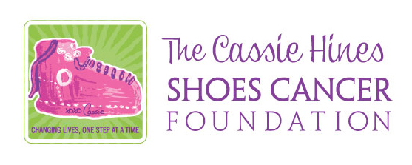

2021-2022 CHSCF Base2Summit Scholarship Application

Section A: Personal Information

Name________________________________________________________________________________
Address_____________________________________________________________________________
______________________________________________________________________________________
Male_______ Female_______
Date of Birth____________________________
Mobile Number_____________________________
Email__________________________________________________________________________________
How did you hear about the CHSCF Base 2 Summit Scholarship?_______________
_________________________________________________________________________________________

Section B: School Information

Name of High School__________________________________________________________________
School Phone Number_______________________________ Year of graduation___________
School of Choice for Fall 2021________________________________________________________
Current Year of School (ie: college freshman, grad school)________________________
Student ID Number (if known)_______________________________________________________

Section C: Medical Information

Diagnosis______________________________________________________________________________
Date of Diagnosis_____________________________________________________________________
Age at Diagnosis______________________________________________________________________
Treatment Center Name _____________________________________________________________
Treatment Center Address__________________________________________________________
Primary Oncologist__________________________________________________________________
Oncologist Phone Number__________________________________________________________

Section D: Essay

When you were diagnosed with cancer you had to adjust to your new “Base” now it’s time to “Reach Your Summit!” In 250-500 words briefly describe where your new “Base” is/was and what your “Summit” will look like. We know your new base started with cancer so don’t spend much time there; we are interested in your bright future. Tell us what you expect to achieve and what motivates you to reach your summit.

- Essays must be typed
- Please attach on a separate piece of paper

Section E: Authorizations

I certify that all statements in this application are TRUE. I understand that this application will become the property of CHSCF. I agree that my essay may be reprinted in part or in full for the purposes of educating, supporting and helping other students of higher learning affected by cancer. I understand ALL Medical information on this application will remain CONFIDENTIAL. I understand that if I receive the CHSCF Base2Summit Scholarship I will be required to submit a photo for use along with my essay for possible website and social media marketing of CHSCF. Other than my first name/last name photo and essay, no other personal information will be used for the purpose of marketing.

SIGNATURE___________________________________________________________________________
DATE___________________________________________________________________________________
PRINTED NAME________________________________________________________________________

HIGHER LEARNING VERIFICATION:

I hereby authorize the registrar of my institution of higher learning to provide a representative of The Cassie Hines Shoes Cancer Foundation with information regarding my enrollment status.

SIGNATURE_____________________________________________________________________________
DATE_____________________________________________________________________________________
PRINTED NAME_________________________________________________________________________

MEDICAL VERIFICATION:

I hereby authorize _____________________________________________________(Oncology Team listed on application) to provide information regarding my date of diagnosis and age at time of diagnosis to a representative of The Cassie Hines Shoes Cancer Foundation in order to support my scholarship application.

SIGNATURE_________________________________________________________________________________
DATE________________________________________________________________________________________
PRINTED NAME____________________________________________________________________________

If you have any questions regarding the application or requirements email our Scholarship Coordinator.
Karen Hines: khines@chscf.org

Note: After meeting all requirements, verification of application with medical team and school of choice, random draw will determine the final winner.

